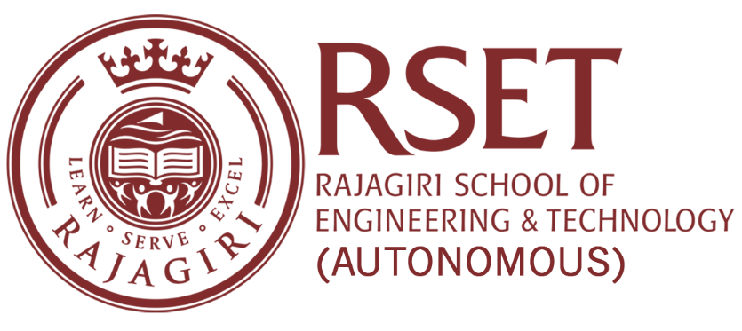

Web link Information

Criteria: 3.7.1
Sl. No. | Content | Web link
1 | Number of collaborative activities during the year for research/ faculty exchange/ student exchange/ internship/ on-the-job training/ project work | https://www.rajagiritech.ac.in/Home/IQAC/index.asp?strPathOnly=DSR/FACULTY/FACULTY%20COLLABORATION/2020-2021/

